

The Brilliant Microschool Multi-Tiered System of Supports

The following is a guide of supports and measures for students who are struggling to adapt to Brilliant Microschool’s learning environment and/or activities. It consists of three levels (tiers) of higher tiers of support and conditions of triggers for each tier are articulated below. The primary measure and indicator of success is the student’s consistent generation of formative assessment learning data, while Social-Emotional Learning (SEL) and Mastery serve as secondary indicators.

The following behaviors identify the norms and expectations of all students.

Formative assessment: students are participating in classroom activities, completing Eduprotocols, Figjams, Nearpods, MobyMax/Khan Academy skills, and other tasks assigned by the teacher, resulting in the generation of formative assessment learning data.

SEL: students uphold all points detailed in the BMS Honor Code, demonstrate appropriate behavior, have their cameras on and are identifiable, and regularly contribute to classroom discussions.

Mastery: students are progressing towards the mastery of knowledge and skills by way of achieving at least a 3 out of 4 on all Performance Tasks identified in each unit.


Tier 1

Tier 1 is our customary Universal classroom learning experience.

The following conditions trigger Tier 1 supports:

Formative assessment: When students are unable to complete classroom activities, including Eduprotocols, Nearpods, and 60 minutes of MobyMax skills per week for 2 weeks in a row, resulting in a lack of formative assessment data and learning opportunities.

SEL: When students do not observe the BMS Honor Code more than two times in two weeks, are absent for 40% or more classes within a three-week period, or adjust their cameras so they are not visible more than once after a two-week adjustment period.

Mastery: students receive less than a 2 out of 4 on two unit Performance Tasks.

Actions if Tier 1 support is Triggered:

- Corrective actions to avoid triggering Tier 2 support:
- Reward Positive Behavior: Teachers will consistently praise and reward positive behavior with verbal recognition and a structured rewards system, such as special privileges or certificates. Clear criteria for rewards help students understand what is expected. This focus on positive actions helps students develop responsibility and motivation.
- Student Choice: if students are not motivated, alternative options will be provided for them to demonstrate the acquisition of knowledge and skills, including both what is to be created (product) and how it is to be created (process). The students’ interests will inform this alternative assignment, but it must provide the opportunity for mastery of the knowledge and skills identified in the respective unit’s power standards.
- Modify/Differentiate Task: Teachers will adjust assignments to match each student's learning style and ability. This includes changing the difficulty, format, or length of tasks. Various supports like extra instructions, visual aids, or different materials will be provided to help students complete their work. The aim is to create a flexible environment where all students can succeed and show their knowledge in ways that suit them best.
- Student-centered goal setting: if students struggle to maintain a healthy amount of focus and organizational skills, a classroom routine will be implemented where the student is coached and supported to set behavioral and/or academic goals on Mondays, with follow-up reflections on Fridays. Students will also share their progress with their parents. (template example)
- Visual Supports: Visual supports help students understand and engage with their learning. These can include timers, schedules, anchor charts, examples, templates, and graphic organizers. Timers aid time management, schedules provide structure, and anchor charts summarize key concepts. Examples and templates offer task models, while graphic organizers help organize information. These tools make learning easier for all students by catering to different learning styles.
- Reset Room: Whenever the BMS Honor Code is not observed, students may be placed in a “reset room”--i.e. a Zoom breakout room–to settle their emotions and reflect on their behavior.
- Conference: if students appear to have emotional, social, or academic challenges, SEL and intervention supports will be implemented in class. When inappropriate behavior is demonstrated, students will reflect in a reset room, inform their parents of their actions, and attend a parent-teacher-student conference.

- Communication and Collaboration: Teachers will maintain open and consistent communication between all parties involved to ensure everyone is aware of the student's progress and any adjustments to the support plan. Engage families as active partners in the support process by providing regular updates on their child's progress and involving them in decision-making meetings. Notify the AP to collaborate on additional behavioral and instructional strategies. Encourage collaboration and input from all stakeholders to ensure a comprehensive support system. Offer resources and training to help families support their child's learning at home, and foster a welcoming environment where families feel comfortable sharing their insights and concerns. This collaborative approach ensures a cohesive and effective support system for the student's success.

- Documentation and Accountability: Teachers will keep updating Toddle with records of all corrective actions provided and their outcomes. This documentation is vital for accountability and for making data-driven decisions about further interventions or support adjustments.
  - If the student is ABLE to reach success within a two-week time frame using corrective actions, no further support will be required.
  - If the student is UNABLE to reach success within a two-week time frame, a PTC (Parent-Teacher Conference) meeting should be held to determine additional Tier 1 corrective actions.
  - If the student is ABLE to reach success within two weeks after the PTC, no further action will be needed.
  - If the student is UNABLE to reach success within two weeks after the PTC, Tier 2 interventions will be triggered.

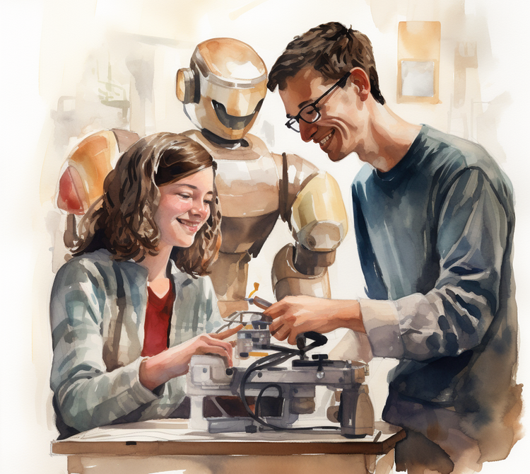

Tier 2

Tier 2 is our first level of additional, Individualized student support.

The following conditions trigger Tier 2:

Formative assessment: After exhausting Tier 1, when students are still unable to complete classroom activities, including Eduprotocols, Nearpods, and 60 minutes of MobyMax skills per week, resulting in a lack of formative assessment data and learning opportunities.

SEL: When students do not observe the BMS Honor Code more than two times in two weeks, are absent for 40% or more of classes within a three-week period, or adjust their cameras so they are not visible more than once after a two-week adjustment period.

Mastery: students receive less than 2 out of 4 on two unit Performance Tasks.

Actions if Tier 2 support is triggered:
By following these steps, we can provide a structured and supportive transition to Tier 2 interventions, ensuring that students receive the targeted support they need to succeed academically and behaviorally.
- Identification and Referral: Teachers or staff identify students who require additional support beyond Tier 1 interventions based on ongoing assessments and observations. These students are then referred to the MTSS support team for Tier 2 interventions by the Assistant Principal of the student’s House.
- Mandated Meeting with AP: Schedule a meeting involving the Assistant Principal, Teacher if appropriate, the parent(s)/guardian(s), and the student. This meeting is crucial for discussing the reasons for the transition to Tier 2 and setting the stage for collaborative support. A call from Parent Support will take place if the parent(s) are unresponsive to the Toddle message within 48hrs.
- Honor Code Review: During the meeting, review the school's Tier 2-Partners in Learning Honor Code Review with the student and parent(s)/guardian(s). This helps reinforce school's expectations and the importance of adhering to them. It's essential to ensure that the student understands the expectations and the consequences of not meeting them.
- Development of a Partners In Learning Action Plan: In addition, during the meeting team will create a detailed Tier 2-Partners in Learning action plan tailored to the student's specific needs. This plan will include:
  - Specific Target Goals: Clearly define the academic and/or behavioral goals the student needs to achieve. These goals should be SMART (Specific, Measurable, Achievable, Relevant, and Time-bound).
  - Intervention Strategies: Outline the specific strategies and interventions (Mandated Meeting with AP and Review of Honor Code, Monitoring, Weekly Check-ins, Class Change, Mandated Peer Tutoring/Mentoring and/or SEL Group, Remedial Math/English, Executive Functioning Group ) that will be implemented to support the student in reaching these goals.
  - Responsibilities and Roles: Clearly delineate the roles and responsibilities of the student, parents/guardians, teachers, and support staff in implementing and supporting the action plan.
- Monitoring and Progress Check-Ins: Establish a schedule for regular weekly check-ins to monitor the student's progress toward the target goals. These check-ins should include:
  - Progress Monitoring Tools: Utilize tools and assessments to track the student's progress. This could involve academic assessments, behavioral logs, attendance records, etc.
  - Regular Meetings: Hold follow-up meetings with the student, parent(s)/guardian(s), and relevant staff to review progress, adjust interventions as needed, and provide feedback and encouragement.
- Communication and Collaboration: Maintain open and consistent communication between all parties involved. This ensures that everyone is aware of the student's progress and any adjustments to the support plan. Encourage collaboration and input from all stakeholders to ensure a comprehensive support system.
- Documentation and Accountability: Keep detailed records of all meetings, plans, and progress reports. This documentation is vital for accountability and for making data-driven decisions about further interventions or support adjustments.
  - If the student upholds the Partners In Learning Action Plan within the given time frame, the student will return to Tier 1.If the student does not adhere to the Partners In Learning Action Plan, Tier 3 will be triggered.
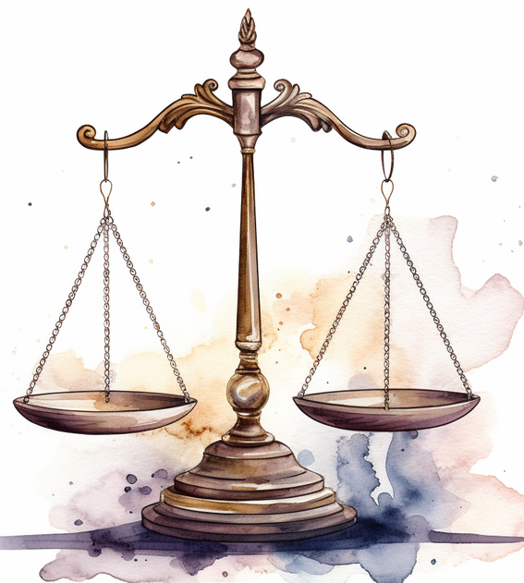
Tier 3

Tier 3 is our highest and Ultimate level of assistance and support.

The following are conditions that trigger Tier 3:

- Failure to adhere to the Partners In Learning Action Plan.
- The parent does not uphold their part of the BMS Honor Code.

Actions if Tier 3 Support is triggered:
By incorporating these steps, we can provide a comprehensive and intensive Tier 3 support plan that effectively addresses the student’s needs through increased 1:1 counselor/psychologist involvement, structured parental engagement, and clear, measurable goals supported by daily check-ins and consistent monitoring. This approach ensures a holistic and collaborative process to support the student’s academic, behavioral, and emotional success, fostering a supportive environment for sustained improvement.
- Identification and Referral: Teachers or staff identify students who require the highest level of support beyond Tiers 1 and 2 based on ongoing assessments, observations, and previous interventions' effectiveness. These students are then referred to the MTSS support team for Tier 3 interventions (Parent Mandated Meeting with Dean and Personal Growth Roadmap, Daily Check-ins, Placement Change (1-1, ESE), Mandated Individual Coaching/Counseling, Mandated Summer School, ABA (when appropriate) based on Tier 2 data.
- 1:1 Counselor/Psychologist Plan: Assign a dedicated school counselor or psychologist to work intensively with the student (at an additional expense to the parent). This plan includes:
  - Initial Comprehensive Assessment: Conduct a detailed assessment of the student’s academic, behavioral, and emotional needs, identifying root causes of challenges.
  - Personalized Intensive Support Plan: Develop a highly individualized support plan that includes frequent 1:1 sessions with the counselor/psychologist, focusing on targeted interventions, skill-building, and coping strategies.
- Mandated Meeting with Dean and Parent(s): Schedule a mandatory meeting involving the Dean, the parent(s)/guardian(s), and the student to discuss the transition to Tier 3 support and establish a collaborative and intensive approach. When appropriate also include AP and Teacher.
  - Review and Reinforce Expectations: Thoroughly review the school’s Honor Code and behavioral expectations with the student and parent(s)/guardian(s).
  - Discuss the Personal Growth Roadmap: Introduce and discuss the individual Personal Growth Roadmap, emphasizing its role in providing clear expectations and structured support.
- Individual Personal Growth Roadmap: Develop a Tier 3-Personal Growth Roadmaptailored to the student’s specific needs, outlining precise behavior/academic goals. This pan will include:
  - SMART Goals: Clearly defined goals that are Specific, Measurable, Achievable, Relevant, and Time-bound.
  - Behavioral Expectations: Detailed behaviors the student is expected to demonstrate or avoid.
  - Empowerment Progress Log: The Empowerment Progress Log is a tool for students to track and celebrate their personal growth. It helps them set goals, monitor their progress, and reflect on their achievements. This log supports students in their journey towards self-improvement and positive change, guiding them towards a more empowered and fulfilling life.

- Daily Check-ins: Implement a structured system of daily check-ins to monitor the student’s progress and provide immediate feedback. This includes:
  - Daily Check-ins: A short meeting at the end of each day to review the student’s progress, provide feedback, and discuss any challenges or successes.
  - Documentation: Maintain a detailed daily log of the student’s behavior/academic performance to track progress and inform future interventions.
- Regular Parental Involvement: Ensure ongoing, intensive communication and involvement of the parent(s)/guardian(s) through:
  - Daily Updates: Provide daily updates to the parents, detailing the student’s achievements and areas for improvement.
  - Weekly Meetings: Schedule weekly meetings with the parents, student, and Dean to review progress, adjust the behavior contract as necessary, and reinforce support strategies.
- Progress Monitoring and Adjustments: Use comprehensive data from daily check-ins and counselor/psychologist sessions to monitor the student’s progress.
  - Frequent Assessments: Conduct frequent assessments to evaluate the effectiveness of the interventions and make necessary adjustments promptly.
  - Feedback Loop: Maintain an open and continuous feedback loop between the student, parents, counselors/psychologists, and teachers to ensure ongoing, data-driven improvement.
- Long-term Support Plan: Develop a long-term, sustainable support plan to ensure the student’s continued success, which may include:
  - Gradual Reduction of Intensity: Slowly reduce the intensity of support as the student meets their goals and demonstrates sustained improvement, while ensuring a smooth transition.
  - Ongoing Monitoring: Continue periodic monitoring and check-ins even after transitioning out of Tier 3 to ensure the student maintains their progress and to provide additional support if needed.
Additional Step for Students Unable to Reach Success with Tier 3
For students who are unable to achieve success with Tier 3 interventions, we will implement the following steps:
- When appropriate students will be transferred to private tutoring where they will have access to work on skills needed to continue their learning. When students demonstrate appropriate skills needed for the group setting classroom in this environment for four consecutive weeks, they may return to a group setting with Tier 3 support, as advised by the Dean of Student Progress or Principal.
